Use Case Specification Report

**Use Case Specification**

CasosDeUsosBIEN

Revision: 0.2

junio 02, 2019

Approval

|  |
| --- |
| The original of this document is approved and signed by:  Name:  Surname:  Title:  Date:  Signature: |

Revision History

|  |  |  |  |
| --- | --- | --- | --- |
| **Revision** | **Date** | **Description** | **Author** |
| 0.1 | <date 1> | <draft> | José Luis y Andrea |
| 0.2 | <date 2> | <release> | José Luis y Andrea |

Table of Contents

Microsoft Word users please click here and press F9 to create Table of Contents.

OpenOffice.org users please remove this text and select Insert Table of Content from menu.

Index of Use-Cases

|  |  |
| --- | --- |
| **UseCase** | **Page** |
| Añadir Evento | Error! Bookmark not defined. |
| Buscar | Error! Bookmark not defined. |
| Cambiar divisa | Error! Bookmark not defined. |
| Cantidad | Error! Bookmark not defined. |
| Categoría | Error! Bookmark not defined. |
| Cliente | Error! Bookmark not defined. |
| Descripción | Error! Bookmark not defined. |
| Editar Evento | Error! Bookmark not defined. |
| Editar información de usuario | Error! Bookmark not defined. |
| Editar Transacción | Error! Bookmark not defined. |
| Elegir mes | Error! Bookmark not defined. |
| Eliminar Evento | Error! Bookmark not defined. |
| Eliminar Transacción | Error! Bookmark not defined. |
| Fecha | Error! Bookmark not defined. |
| Gasto | Error! Bookmark not defined. |
| Ingreso | Error! Bookmark not defined. |
| Migración de datos | Error! Bookmark not defined. |
| Nueva transacción | Error! Bookmark not defined. |
| Resumen de transacciones | Error! Bookmark not defined. |
| Tipo | Error! Bookmark not defined. |
| Visualizar datos | Error! Bookmark not defined. |
| Visualizar en factura | Error! Bookmark not defined. |
| Visualizar en formato gráfico | Error! Bookmark not defined. |
| Visualizar en formato tabular | Error! Bookmark not defined. |
| Visualizar estadística compleja | Error! Bookmark not defined. |
| Visualizar estadística simple | Error! Bookmark not defined. |
| Visualizar por filtrado | Error! Bookmark not defined. |

# Introduction

## Purpose

<This Document describes Use Case Specification Report.>

## Scope

<This Document intends to describe use case specification for the system.>

## Overview

<Describe what the document contains and explain how the document is organized.>

# Actor Summary

|  |  |
| --- | --- |
| **Primary Actor** | **Use Cases** |
| Base de Datos | * Añadir Evento      * Balance mensual      * Buscar      * Buscar      * Calendario de eventos      * Cambiar divisa      * Editar Evento      * Editar información de usuario      * Editar Transacción      * Elegir mes      * Eliminar Evento      * Eliminar Transacción      * Hoja de contactos      * Nueva transacción      * Visualizar datos |
| Usuario | * Añadir Evento      * Balance mensual      * Buscar      * Calendario de eventos      * Cambiar divisa      * Editar Evento      * Editar información de usuario      * Editar Transacción      * Elegir mes      * Eliminar Evento      * Eliminar Transacción      * Hoja de contactos      * Migración de datos      * Nueva transacción      * Visualizar datos |

# Use Case: Calendario Diagram

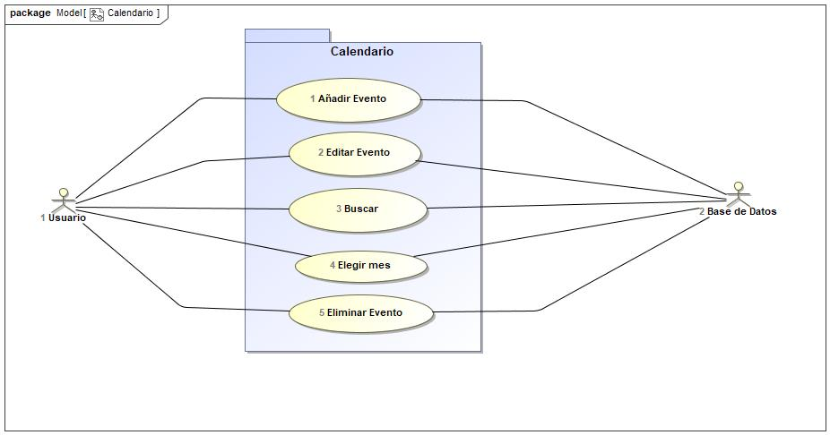

## Añadir Evento Use Case

|  |  |  |  |
| --- | --- | --- | --- |
| **Use Case Name** | Añadir Evento | ID | 1 |
| **Complexity** | Average Complexity | | |
| **Description** |  | | |
| **Actors** | * Base de Datos * Usuario | | |
| **Goal** |  | | |
| **Assumption** |  | | |
| **Non Functional Requirements** |  | | |
| **Pre Condition** | El nombre de usuario y el correo no debe estar en la base de datos | | |
| **Post Condition** |  | | |
| **Constraints** |  | | |

|  |  |
| --- | --- |
| **Relations** | |
| **Association** | * Base de Datos Actor * Usuario Actor |
| **Include** |  |
| **Extend** |  |
| **Generalization** |  |

|  |  |
| --- | --- |
| **Scenarios** | |
| **Basic Flow of Events** |  |
| **Basic Flow of Events Diagrams** |  |
| **Alternative Flow of Events** | Si el usuario ya está registrado o el correo ya está usado, el sistema te pide que pruebes con otro nombre de usuario u otro correo. |
| **Alternative Flow of Events Diagrams** |  |
| **Exceptional Flow of Events** |  |
| **Exceptional Flow of Events Diagrams** |  |

## Buscar Use Case

|  |  |  |  |
| --- | --- | --- | --- |
| **Use Case Name** | Buscar | ID | 3 |
| **Complexity** | Average Complexity | | |
| **Description** |  | | |
| **Actors** | * Base de Datos * Usuario | | |
| **Goal** |  | | |
| **Assumption** |  | | |
| **Non Functional Requirements** |  | | |
| **Pre Condition** |  | | |
| **Post Condition** |  | | |
| **Constraints** |  | | |

|  |  |
| --- | --- |
| **Relations** | |
| **Association** | * Base de Datos Actor * Usuario Actor |
| **Include** |  |
| **Extend** |  |
| **Generalization** |  |

|  |  |
| --- | --- |
| **Scenarios** | |
| **Basic Flow of Events** |  |
| **Basic Flow of Events Diagrams** |  |
| **Alternative Flow of Events** |  |
| **Alternative Flow of Events Diagrams** |  |
| **Exceptional Flow of Events** |  |
| **Exceptional Flow of Events Diagrams** |  |

## Editar Evento Use Case

|  |  |  |  |
| --- | --- | --- | --- |
| **Use Case Name** | Editar Evento | ID | 2 |
| **Complexity** | Average Complexity | | |
| **Description** |  | | |
| **Actors** | * Base de Datos * Usuario | | |
| **Goal** |  | | |
| **Assumption** |  | | |
| **Non Functional Requirements** |  | | |
| **Pre Condition** | El usuario y contraseña coinciden con la base de datos. | | |
| **Post Condition** |  | | |
| **Constraints** |  | | |

|  |  |
| --- | --- |
| **Relations** | |
| **Association** | * Base de Datos Actor * Usuario Actor |
| **Include** |  |
| **Extend** |  |
| **Generalization** |  |

|  |  |
| --- | --- |
| **Scenarios** | |
| **Basic Flow of Events** |  |
| **Basic Flow of Events Diagrams** |  |
| **Alternative Flow of Events** | Si el usuario o la contraseña no coinciden, el sistema te pide que vuelvas a introducir los datos. Si fallas 3 veces, el sistema no te deja realizar más intentos en una hora y te manda un aviso al correo vinculado a la cuenta con ese nombre de usuario. |
| **Alternative Flow of Events Diagrams** |  |
| **Exceptional Flow of Events** |  |
| **Exceptional Flow of Events Diagrams** |  |

## Elegir mes Use Case

|  |  |  |  |
| --- | --- | --- | --- |
| **Use Case Name** | Elegir mes | ID | 4 |
| **Complexity** | Average Complexity | | |
| **Description** |  | | |
| **Actors** | * Base de Datos * Usuario | | |
| **Goal** |  | | |
| **Assumption** |  | | |
| **Non Functional Requirements** |  | | |
| **Pre Condition** |  | | |
| **Post Condition** |  | | |
| **Constraints** |  | | |

|  |  |
| --- | --- |
| **Relations** | |
| **Association** | * Base de Datos Actor * Usuario Actor |
| **Include** |  |
| **Extend** |  |
| **Generalization** |  |

|  |  |
| --- | --- |
| **Scenarios** | |
| **Basic Flow of Events** |  |
| **Basic Flow of Events Diagrams** |  |
| **Alternative Flow of Events** |  |
| **Alternative Flow of Events Diagrams** |  |
| **Exceptional Flow of Events** |  |
| **Exceptional Flow of Events Diagrams** |  |

## Eliminar Evento Use Case

|  |  |  |  |
| --- | --- | --- | --- |
| **Use Case Name** | Eliminar Evento | ID | 5 |
| **Complexity** | Average Complexity | | |
| **Description** |  | | |
| **Actors** | * Base de Datos * Usuario | | |
| **Goal** |  | | |
| **Assumption** |  | | |
| **Non Functional Requirements** |  | | |
| **Pre Condition** |  | | |
| **Post Condition** |  | | |
| **Constraints** |  | | |

|  |  |
| --- | --- |
| **Relations** | |
| **Association** | * Base de Datos Actor * Usuario Actor |
| **Include** |  |
| **Extend** |  |
| **Generalization** |  |

|  |  |
| --- | --- |
| **Scenarios** | |
| **Basic Flow of Events** |  |
| **Basic Flow of Events Diagrams** |  |
| **Alternative Flow of Events** |  |
| **Alternative Flow of Events Diagrams** |  |
| **Exceptional Flow of Events** |  |
| **Exceptional Flow of Events Diagrams** |  |

# Use Case: Contactos Diagram

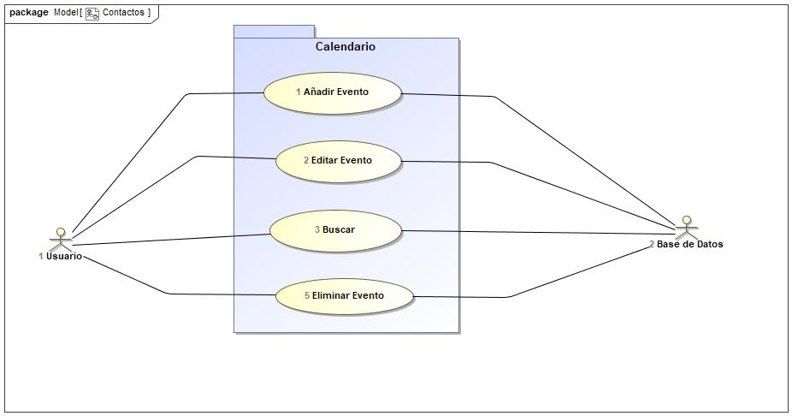

## Añadir Evento Use Case

|  |  |  |  |
| --- | --- | --- | --- |
| **Use Case Name** | Añadir Evento | ID | 1 |
| **Complexity** | Average Complexity | | |
| **Description** |  | | |
| **Actors** | * Base de Datos * Usuario | | |
| **Goal** |  | | |
| **Assumption** |  | | |
| **Non Functional Requirements** |  | | |
| **Pre Condition** | El nombre de usuario y el correo no debe estar en la base de datos | | |
| **Post Condition** |  | | |
| **Constraints** |  | | |

|  |  |
| --- | --- |
| **Relations** | |
| **Association** | * Base de Datos Actor * Usuario Actor |
| **Include** |  |
| **Extend** |  |
| **Generalization** |  |

|  |  |
| --- | --- |
| **Scenarios** | |
| **Basic Flow of Events** |  |
| **Basic Flow of Events Diagrams** |  |
| **Alternative Flow of Events** | Si el usuario ya está registrado o el correo ya está usado, el sistema te pide que pruebes con otro nombre de usuario u otro correo. |
| **Alternative Flow of Events Diagrams** |  |
| **Exceptional Flow of Events** |  |
| **Exceptional Flow of Events Diagrams** |  |

## Buscar Use Case

|  |  |  |  |
| --- | --- | --- | --- |
| **Use Case Name** | Buscar | ID | 3 |
| **Complexity** | Average Complexity | | |
| **Description** |  | | |
| **Actors** | * Base de Datos * Usuario | | |
| **Goal** |  | | |
| **Assumption** |  | | |
| **Non Functional Requirements** |  | | |
| **Pre Condition** |  | | |
| **Post Condition** |  | | |
| **Constraints** |  | | |

|  |  |
| --- | --- |
| **Relations** | |
| **Association** | * Base de Datos Actor * Usuario Actor |
| **Include** |  |
| **Extend** |  |
| **Generalization** |  |

|  |  |
| --- | --- |
| **Scenarios** | |
| **Basic Flow of Events** |  |
| **Basic Flow of Events Diagrams** |  |
| **Alternative Flow of Events** |  |
| **Alternative Flow of Events Diagrams** |  |
| **Exceptional Flow of Events** |  |
| **Exceptional Flow of Events Diagrams** |  |

## Editar Evento Use Case

|  |  |  |  |
| --- | --- | --- | --- |
| **Use Case Name** | Editar Evento | ID | 2 |
| **Complexity** | Average Complexity | | |
| **Description** |  | | |
| **Actors** | * Base de Datos * Usuario | | |
| **Goal** |  | | |
| **Assumption** |  | | |
| **Non Functional Requirements** |  | | |
| **Pre Condition** | El usuario y contraseña coinciden con la base de datos. | | |
| **Post Condition** |  | | |
| **Constraints** |  | | |

|  |  |
| --- | --- |
| **Relations** | |
| **Association** | * Base de Datos Actor * Usuario Actor |
| **Include** |  |
| **Extend** |  |
| **Generalization** |  |

|  |  |
| --- | --- |
| **Scenarios** | |
| **Basic Flow of Events** |  |
| **Basic Flow of Events Diagrams** |  |
| **Alternative Flow of Events** | Si el usuario o la contraseña no coinciden, el sistema te pide que vuelvas a introducir los datos. Si fallas 3 veces, el sistema no te deja realizar más intentos en una hora y te manda un aviso al correo vinculado a la cuenta con ese nombre de usuario. |
| **Alternative Flow of Events Diagrams** |  |
| **Exceptional Flow of Events** |  |
| **Exceptional Flow of Events Diagrams** |  |

## Eliminar Evento Use Case

|  |  |  |  |
| --- | --- | --- | --- |
| **Use Case Name** | Eliminar Evento | ID | 5 |
| **Complexity** | Average Complexity | | |
| **Description** |  | | |
| **Actors** | * Base de Datos * Usuario | | |
| **Goal** |  | | |
| **Assumption** |  | | |
| **Non Functional Requirements** |  | | |
| **Pre Condition** |  | | |
| **Post Condition** |  | | |
| **Constraints** |  | | |

|  |  |
| --- | --- |
| **Relations** | |
| **Association** | * Base de Datos Actor * Usuario Actor |
| **Include** |  |
| **Extend** |  |
| **Generalization** |  |

|  |  |
| --- | --- |
| **Scenarios** | |
| **Basic Flow of Events** |  |
| **Basic Flow of Events Diagrams** |  |
| **Alternative Flow of Events** |  |
| **Alternative Flow of Events Diagrams** |  |
| **Exceptional Flow of Events** |  |
| **Exceptional Flow of Events Diagrams** |  |

# Use Case: Cuenta de Usuario Diagram

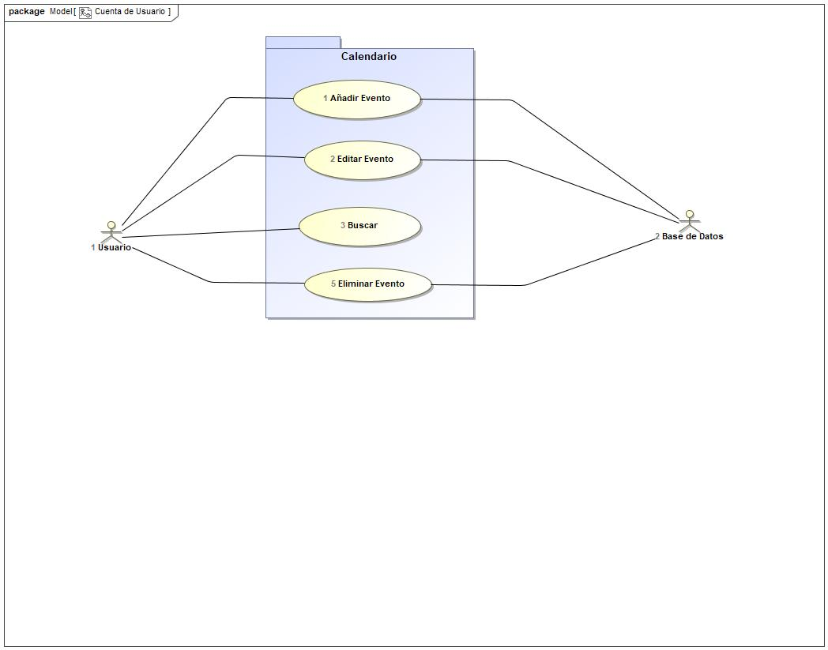

## Añadir Evento Use Case

|  |  |  |  |
| --- | --- | --- | --- |
| **Use Case Name** | Añadir Evento | ID | 1 |
| **Complexity** | Average Complexity | | |
| **Description** |  | | |
| **Actors** | * Base de Datos * Usuario | | |
| **Goal** |  | | |
| **Assumption** |  | | |
| **Non Functional Requirements** |  | | |
| **Pre Condition** | El nombre de usuario y el correo no debe estar en la base de datos | | |
| **Post Condition** |  | | |
| **Constraints** |  | | |

|  |  |
| --- | --- |
| **Relations** | |
| **Association** | * Base de Datos Actor * Usuario Actor |
| **Include** |  |
| **Extend** |  |
| **Generalization** |  |

|  |  |
| --- | --- |
| **Scenarios** | |
| **Basic Flow of Events** |  |
| **Basic Flow of Events Diagrams** |  |
| **Alternative Flow of Events** | Si el usuario ya está registrado o el correo ya está usado, el sistema te pide que pruebes con otro nombre de usuario u otro correo. |
| **Alternative Flow of Events Diagrams** |  |
| **Exceptional Flow of Events** |  |
| **Exceptional Flow of Events Diagrams** |  |

## Buscar Use Case

|  |  |  |  |
| --- | --- | --- | --- |
| **Use Case Name** | Buscar | ID | 3 |
| **Complexity** | Average Complexity | | |
| **Description** |  | | |
| **Actors** | * Base de Datos * Usuario | | |
| **Goal** |  | | |
| **Assumption** |  | | |
| **Non Functional Requirements** |  | | |
| **Pre Condition** |  | | |
| **Post Condition** |  | | |
| **Constraints** |  | | |

|  |  |
| --- | --- |
| **Relations** | |
| **Association** | * Base de Datos Actor * Usuario Actor |
| **Include** |  |
| **Extend** |  |
| **Generalization** |  |

|  |  |
| --- | --- |
| **Scenarios** | |
| **Basic Flow of Events** |  |
| **Basic Flow of Events Diagrams** |  |
| **Alternative Flow of Events** |  |
| **Alternative Flow of Events Diagrams** |  |
| **Exceptional Flow of Events** |  |
| **Exceptional Flow of Events Diagrams** |  |

## Editar Evento Use Case

|  |  |  |  |
| --- | --- | --- | --- |
| **Use Case Name** | Editar Evento | ID | 2 |
| **Complexity** | Average Complexity | | |
| **Description** |  | | |
| **Actors** | * Base de Datos * Usuario | | |
| **Goal** |  | | |
| **Assumption** |  | | |
| **Non Functional Requirements** |  | | |
| **Pre Condition** | El usuario y contraseña coinciden con la base de datos. | | |
| **Post Condition** |  | | |
| **Constraints** |  | | |

|  |  |
| --- | --- |
| **Relations** | |
| **Association** | * Base de Datos Actor * Usuario Actor |
| **Include** |  |
| **Extend** |  |
| **Generalization** |  |

|  |  |
| --- | --- |
| **Scenarios** | |
| **Basic Flow of Events** |  |
| **Basic Flow of Events Diagrams** |  |
| **Alternative Flow of Events** | Si el usuario o la contraseña no coinciden, el sistema te pide que vuelvas a introducir los datos. Si fallas 3 veces, el sistema no te deja realizar más intentos en una hora y te manda un aviso al correo vinculado a la cuenta con ese nombre de usuario. |
| **Alternative Flow of Events Diagrams** |  |
| **Exceptional Flow of Events** |  |
| **Exceptional Flow of Events Diagrams** |  |

## Eliminar Evento Use Case

|  |  |  |  |
| --- | --- | --- | --- |
| **Use Case Name** | Eliminar Evento | ID | 5 |
| **Complexity** | Average Complexity | | |
| **Description** |  | | |
| **Actors** | * Base de Datos * Usuario | | |
| **Goal** |  | | |
| **Assumption** |  | | |
| **Non Functional Requirements** |  | | |
| **Pre Condition** |  | | |
| **Post Condition** |  | | |
| **Constraints** |  | | |

|  |  |
| --- | --- |
| **Relations** | |
| **Association** | * Base de Datos Actor * Usuario Actor |
| **Include** |  |
| **Extend** |  |
| **Generalization** |  |

|  |  |
| --- | --- |
| **Scenarios** | |
| **Basic Flow of Events** |  |
| **Basic Flow of Events Diagrams** |  |
| **Alternative Flow of Events** |  |
| **Alternative Flow of Events Diagrams** |  |
| **Exceptional Flow of Events** |  |
| **Exceptional Flow of Events Diagrams** |  |

# Use Case: Funcionalidades Diagram

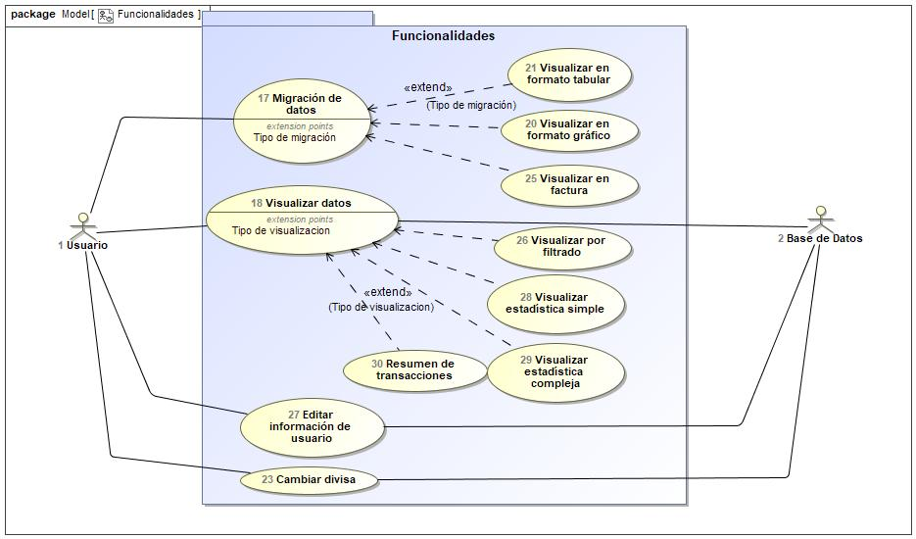

## Cambiar divisa Use Case

|  |  |  |  |
| --- | --- | --- | --- |
| **Use Case Name** | Cambiar divisa | ID | 23 |
| **Complexity** | Average Complexity | | |
| **Description** |  | | |
| **Actors** | * Base de Datos * Usuario | | |
| **Goal** |  | | |
| **Assumption** |  | | |
| **Non Functional Requirements** |  | | |
| **Pre Condition** |  | | |
| **Post Condition** |  | | |
| **Constraints** |  | | |

|  |  |
| --- | --- |
| **Relations** | |
| **Association** | * Base de Datos Actor * Usuario Actor |
| **Include** |  |
| **Extend** |  |
| **Generalization** |  |

|  |  |
| --- | --- |
| **Scenarios** | |
| **Basic Flow of Events** |  |
| **Basic Flow of Events Diagrams** |  |
| **Alternative Flow of Events** |  |
| **Alternative Flow of Events Diagrams** |  |
| **Exceptional Flow of Events** |  |
| **Exceptional Flow of Events Diagrams** |  |

## Editar información de usuario Use Case

|  |  |  |  |
| --- | --- | --- | --- |
| **Use Case Name** | Editar información de usuario | ID | 27 |
| **Complexity** | Average Complexity | | |
| **Description** |  | | |
| **Actors** | * Base de Datos * Usuario | | |
| **Goal** |  | | |
| **Assumption** |  | | |
| **Non Functional Requirements** |  | | |
| **Pre Condition** |  | | |
| **Post Condition** |  | | |
| **Constraints** |  | | |

|  |  |
| --- | --- |
| **Relations** | |
| **Association** | * Base de Datos Actor * Usuario Actor |
| **Include** |  |
| **Extend** |  |
| **Generalization** |  |

|  |  |
| --- | --- |
| **Scenarios** | |
| **Basic Flow of Events** |  |
| **Basic Flow of Events Diagrams** |  |
| **Alternative Flow of Events** |  |
| **Alternative Flow of Events Diagrams** |  |
| **Exceptional Flow of Events** |  |
| **Exceptional Flow of Events Diagrams** |  |

## Migración de datos Use Case

|  |  |  |  |
| --- | --- | --- | --- |
| **Use Case Name** | Migración de datos | ID | 17 |
| **Complexity** | Average Complexity | | |
| **Description** |  | | |
| **Actors** | * Usuario | | |
| **Goal** |  | | |
| **Assumption** |  | | |
| **Non Functional Requirements** |  | | |
| **Pre Condition** |  | | |
| **Post Condition** |  | | |
| **Constraints** |  | | |

|  |  |
| --- | --- |
| **Relations** | |
| **Association** | * Usuario Actor |
| **Include** |  |
| **Extend** |  |
| **Generalization** |  |

|  |  |
| --- | --- |
| **Scenarios** | |
| **Basic Flow of Events** |  |
| **Basic Flow of Events Diagrams** |  |
| **Alternative Flow of Events** |  |
| **Alternative Flow of Events Diagrams** |  |
| **Exceptional Flow of Events** |  |
| **Exceptional Flow of Events Diagrams** |  |

## Resumen de transacciones Use Case

|  |  |  |  |
| --- | --- | --- | --- |
| **Use Case Name** | Resumen de transacciones | ID | 30 |
| **Complexity** | Average Complexity | | |
| **Description** |  | | |
| **Actors** |  | | |
| **Goal** |  | | |
| **Assumption** |  | | |
| **Non Functional Requirements** |  | | |
| **Pre Condition** |  | | |
| **Post Condition** |  | | |
| **Constraints** |  | | |

|  |  |
| --- | --- |
| **Relations** | |
| **Association** |  |
| **Include** |  |
| **Extend** | * Visualizar datos UseCase |
| **Generalization** |  |

|  |  |
| --- | --- |
| **Scenarios** | |
| **Basic Flow of Events** |  |
| **Basic Flow of Events Diagrams** |  |
| **Alternative Flow of Events** |  |
| **Alternative Flow of Events Diagrams** |  |
| **Exceptional Flow of Events** |  |
| **Exceptional Flow of Events Diagrams** |  |

## Visualizar datos Use Case

|  |  |  |  |
| --- | --- | --- | --- |
| **Use Case Name** | Visualizar datos | ID | 18 |
| **Complexity** | Average Complexity | | |
| **Description** |  | | |
| **Actors** | * Base de Datos * Usuario | | |
| **Goal** |  | | |
| **Assumption** |  | | |
| **Non Functional Requirements** |  | | |
| **Pre Condition** |  | | |
| **Post Condition** |  | | |
| **Constraints** |  | | |

|  |  |
| --- | --- |
| **Relations** | |
| **Association** | * Base de Datos Actor * Usuario Actor |
| **Include** |  |
| **Extend** |  |
| **Generalization** |  |

|  |  |
| --- | --- |
| **Scenarios** | |
| **Basic Flow of Events** |  |
| **Basic Flow of Events Diagrams** |  |
| **Alternative Flow of Events** |  |
| **Alternative Flow of Events Diagrams** |  |
| **Exceptional Flow of Events** |  |
| **Exceptional Flow of Events Diagrams** |  |

## Visualizar en factura Use Case

|  |  |  |  |
| --- | --- | --- | --- |
| **Use Case Name** | Visualizar en factura | ID | 25 |
| **Complexity** | Average Complexity | | |
| **Description** |  | | |
| **Actors** |  | | |
| **Goal** |  | | |
| **Assumption** |  | | |
| **Non Functional Requirements** |  | | |
| **Pre Condition** |  | | |
| **Post Condition** |  | | |
| **Constraints** |  | | |

|  |  |
| --- | --- |
| **Relations** | |
| **Association** |  |
| **Include** |  |
| **Extend** | * Migración de datos UseCase |
| **Generalization** |  |

|  |  |
| --- | --- |
| **Scenarios** | |
| **Basic Flow of Events** |  |
| **Basic Flow of Events Diagrams** |  |
| **Alternative Flow of Events** |  |
| **Alternative Flow of Events Diagrams** |  |
| **Exceptional Flow of Events** |  |
| **Exceptional Flow of Events Diagrams** |  |

## Visualizar en formato gráfico Use Case

|  |  |  |  |
| --- | --- | --- | --- |
| **Use Case Name** | Visualizar en formato gráfico | ID | 20 |
| **Complexity** | Average Complexity | | |
| **Description** |  | | |
| **Actors** |  | | |
| **Goal** |  | | |
| **Assumption** |  | | |
| **Non Functional Requirements** |  | | |
| **Pre Condition** |  | | |
| **Post Condition** |  | | |
| **Constraints** |  | | |

|  |  |
| --- | --- |
| **Relations** | |
| **Association** |  |
| **Include** |  |
| **Extend** | * Migración de datos UseCase |
| **Generalization** |  |

|  |  |
| --- | --- |
| **Scenarios** | |
| **Basic Flow of Events** |  |
| **Basic Flow of Events Diagrams** |  |
| **Alternative Flow of Events** |  |
| **Alternative Flow of Events Diagrams** |  |
| **Exceptional Flow of Events** |  |
| **Exceptional Flow of Events Diagrams** |  |

## Visualizar en formato tabular Use Case

|  |  |  |  |
| --- | --- | --- | --- |
| **Use Case Name** | Visualizar en formato tabular | ID | 21 |
| **Complexity** | Average Complexity | | |
| **Description** |  | | |
| **Actors** |  | | |
| **Goal** |  | | |
| **Assumption** |  | | |
| **Non Functional Requirements** |  | | |
| **Pre Condition** |  | | |
| **Post Condition** |  | | |
| **Constraints** |  | | |

|  |  |
| --- | --- |
| **Relations** | |
| **Association** |  |
| **Include** |  |
| **Extend** | * Migración de datos UseCase |
| **Generalization** |  |

|  |  |
| --- | --- |
| **Scenarios** | |
| **Basic Flow of Events** |  |
| **Basic Flow of Events Diagrams** |  |
| **Alternative Flow of Events** |  |
| **Alternative Flow of Events Diagrams** |  |
| **Exceptional Flow of Events** |  |
| **Exceptional Flow of Events Diagrams** |  |

## Visualizar estadística compleja Use Case

|  |  |  |  |
| --- | --- | --- | --- |
| **Use Case Name** | Visualizar estadística compleja | ID | 29 |
| **Complexity** | Average Complexity | | |
| **Description** |  | | |
| **Actors** |  | | |
| **Goal** |  | | |
| **Assumption** |  | | |
| **Non Functional Requirements** |  | | |
| **Pre Condition** |  | | |
| **Post Condition** |  | | |
| **Constraints** |  | | |

|  |  |
| --- | --- |
| **Relations** | |
| **Association** |  |
| **Include** |  |
| **Extend** | * Visualizar datos UseCase |
| **Generalization** |  |

|  |  |
| --- | --- |
| **Scenarios** | |
| **Basic Flow of Events** |  |
| **Basic Flow of Events Diagrams** |  |
| **Alternative Flow of Events** |  |
| **Alternative Flow of Events Diagrams** |  |
| **Exceptional Flow of Events** |  |
| **Exceptional Flow of Events Diagrams** |  |

## Visualizar estadística simple Use Case

|  |  |  |  |
| --- | --- | --- | --- |
| **Use Case Name** | Visualizar estadística simple | ID | 28 |
| **Complexity** | Average Complexity | | |
| **Description** |  | | |
| **Actors** |  | | |
| **Goal** |  | | |
| **Assumption** |  | | |
| **Non Functional Requirements** |  | | |
| **Pre Condition** |  | | |
| **Post Condition** |  | | |
| **Constraints** |  | | |

|  |  |
| --- | --- |
| **Relations** | |
| **Association** |  |
| **Include** |  |
| **Extend** | * Visualizar datos UseCase |
| **Generalization** |  |

|  |  |
| --- | --- |
| **Scenarios** | |
| **Basic Flow of Events** |  |
| **Basic Flow of Events Diagrams** |  |
| **Alternative Flow of Events** |  |
| **Alternative Flow of Events Diagrams** |  |
| **Exceptional Flow of Events** |  |
| **Exceptional Flow of Events Diagrams** |  |

## Visualizar por filtrado Use Case

|  |  |  |  |
| --- | --- | --- | --- |
| **Use Case Name** | Visualizar por filtrado | ID | 26 |
| **Complexity** | Average Complexity | | |
| **Description** |  | | |
| **Actors** |  | | |
| **Goal** |  | | |
| **Assumption** |  | | |
| **Non Functional Requirements** |  | | |
| **Pre Condition** |  | | |
| **Post Condition** |  | | |
| **Constraints** |  | | |

|  |  |
| --- | --- |
| **Relations** | |
| **Association** |  |
| **Include** |  |
| **Extend** | * Visualizar datos UseCase |
| **Generalization** |  |

|  |  |
| --- | --- |
| **Scenarios** | |
| **Basic Flow of Events** |  |
| **Basic Flow of Events Diagrams** |  |
| **Alternative Flow of Events** |  |
| **Alternative Flow of Events Diagrams** |  |
| **Exceptional Flow of Events** |  |
| **Exceptional Flow of Events Diagrams** |  |

# Use Case: Transacciones Diagram

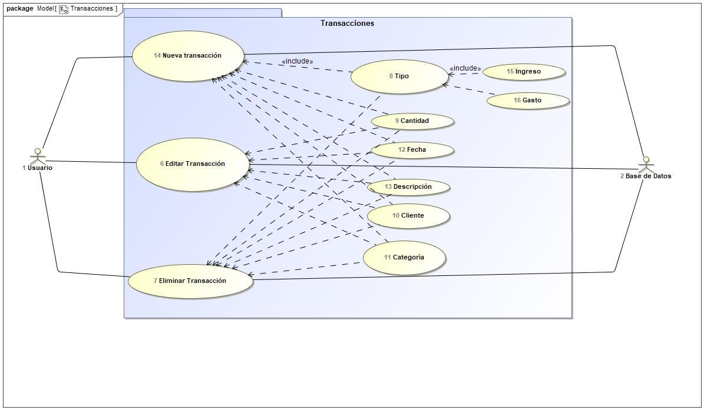

## Cantidad Use Case

|  |  |  |  |
| --- | --- | --- | --- |
| **Use Case Name** | Cantidad | ID | 9 |
| **Complexity** | Average Complexity | | |
| **Description** |  | | |
| **Actors** |  | | |
| **Goal** |  | | |
| **Assumption** |  | | |
| **Non Functional Requirements** |  | | |
| **Pre Condition** |  | | |
| **Post Condition** |  | | |
| **Constraints** |  | | |

|  |  |
| --- | --- |
| **Relations** | |
| **Association** |  |
| **Include** | * Editar Transacción UseCase * Eliminar Transacción UseCase * Nueva transacción UseCase |
| **Extend** |  |
| **Generalization** |  |

|  |  |
| --- | --- |
| **Scenarios** | |
| **Basic Flow of Events** |  |
| **Basic Flow of Events Diagrams** |  |
| **Alternative Flow of Events** |  |
| **Alternative Flow of Events Diagrams** |  |
| **Exceptional Flow of Events** |  |
| **Exceptional Flow of Events Diagrams** |  |

## Categoría Use Case

|  |  |  |  |
| --- | --- | --- | --- |
| **Use Case Name** | Categoría | ID | 11 |
| **Complexity** | Average Complexity | | |
| **Description** |  | | |
| **Actors** |  | | |
| **Goal** |  | | |
| **Assumption** |  | | |
| **Non Functional Requirements** |  | | |
| **Pre Condition** |  | | |
| **Post Condition** |  | | |
| **Constraints** |  | | |

|  |  |
| --- | --- |
| **Relations** | |
| **Association** |  |
| **Include** | * Editar Transacción UseCase * Eliminar Transacción UseCase * Nueva transacción UseCase |
| **Extend** |  |
| **Generalization** |  |

|  |  |
| --- | --- |
| **Scenarios** | |
| **Basic Flow of Events** |  |
| **Basic Flow of Events Diagrams** |  |
| **Alternative Flow of Events** |  |
| **Alternative Flow of Events Diagrams** |  |
| **Exceptional Flow of Events** |  |
| **Exceptional Flow of Events Diagrams** |  |

## Cliente Use Case

|  |  |  |  |
| --- | --- | --- | --- |
| **Use Case Name** | Cliente | ID | 10 |
| **Complexity** | Average Complexity | | |
| **Description** |  | | |
| **Actors** |  | | |
| **Goal** |  | | |
| **Assumption** |  | | |
| **Non Functional Requirements** |  | | |
| **Pre Condition** |  | | |
| **Post Condition** |  | | |
| **Constraints** |  | | |

|  |  |
| --- | --- |
| **Relations** | |
| **Association** |  |
| **Include** | * Editar Transacción UseCase * Eliminar Transacción UseCase * Nueva transacción UseCase |
| **Extend** |  |
| **Generalization** |  |

|  |  |
| --- | --- |
| **Scenarios** | |
| **Basic Flow of Events** |  |
| **Basic Flow of Events Diagrams** |  |
| **Alternative Flow of Events** |  |
| **Alternative Flow of Events Diagrams** |  |
| **Exceptional Flow of Events** |  |
| **Exceptional Flow of Events Diagrams** |  |

## Descripción Use Case

|  |  |  |  |
| --- | --- | --- | --- |
| **Use Case Name** | Descripción | ID | 13 |
| **Complexity** | Average Complexity | | |
| **Description** |  | | |
| **Actors** |  | | |
| **Goal** |  | | |
| **Assumption** |  | | |
| **Non Functional Requirements** |  | | |
| **Pre Condition** |  | | |
| **Post Condition** |  | | |
| **Constraints** |  | | |

|  |  |
| --- | --- |
| **Relations** | |
| **Association** |  |
| **Include** | * Editar Transacción UseCase * Eliminar Transacción UseCase * Nueva transacción UseCase |
| **Extend** |  |
| **Generalization** |  |

|  |  |
| --- | --- |
| **Scenarios** | |
| **Basic Flow of Events** |  |
| **Basic Flow of Events Diagrams** |  |
| **Alternative Flow of Events** |  |
| **Alternative Flow of Events Diagrams** |  |
| **Exceptional Flow of Events** |  |
| **Exceptional Flow of Events Diagrams** |  |

## Editar Transacción Use Case

|  |  |  |  |
| --- | --- | --- | --- |
| **Use Case Name** | Editar Transacción | ID | 6 |
| **Complexity** | Average Complexity | | |
| **Description** |  | | |
| **Actors** | * Base de Datos * Usuario | | |
| **Goal** |  | | |
| **Assumption** |  | | |
| **Non Functional Requirements** |  | | |
| **Pre Condition** |  | | |
| **Post Condition** |  | | |
| **Constraints** |  | | |

|  |  |
| --- | --- |
| **Relations** | |
| **Association** | * Base de Datos Actor * Usuario Actor |
| **Include** |  |
| **Extend** |  |
| **Generalization** |  |

|  |  |
| --- | --- |
| **Scenarios** | |
| **Basic Flow of Events** |  |
| **Basic Flow of Events Diagrams** |  |
| **Alternative Flow of Events** |  |
| **Alternative Flow of Events Diagrams** |  |
| **Exceptional Flow of Events** |  |
| **Exceptional Flow of Events Diagrams** |  |

## Eliminar Transacción Use Case

|  |  |  |  |
| --- | --- | --- | --- |
| **Use Case Name** | Eliminar Transacción | ID | 7 |
| **Complexity** | Average Complexity | | |
| **Description** |  | | |
| **Actors** | * Base de Datos * Usuario | | |
| **Goal** |  | | |
| **Assumption** |  | | |
| **Non Functional Requirements** |  | | |
| **Pre Condition** |  | | |
| **Post Condition** |  | | |
| **Constraints** |  | | |

|  |  |
| --- | --- |
| **Relations** | |
| **Association** | * Base de Datos Actor * Usuario Actor |
| **Include** |  |
| **Extend** |  |
| **Generalization** |  |

|  |  |
| --- | --- |
| **Scenarios** | |
| **Basic Flow of Events** |  |
| **Basic Flow of Events Diagrams** |  |
| **Alternative Flow of Events** |  |
| **Alternative Flow of Events Diagrams** |  |
| **Exceptional Flow of Events** |  |
| **Exceptional Flow of Events Diagrams** |  |

## Fecha Use Case

|  |  |  |  |
| --- | --- | --- | --- |
| **Use Case Name** | Fecha | ID | 12 |
| **Complexity** | Average Complexity | | |
| **Description** |  | | |
| **Actors** |  | | |
| **Goal** |  | | |
| **Assumption** |  | | |
| **Non Functional Requirements** |  | | |
| **Pre Condition** |  | | |
| **Post Condition** |  | | |
| **Constraints** |  | | |

|  |  |
| --- | --- |
| **Relations** | |
| **Association** |  |
| **Include** | * Editar Transacción UseCase * Editar Transacción UseCase * Eliminar Transacción UseCase * Nueva transacción UseCase |
| **Extend** |  |
| **Generalization** |  |

|  |  |
| --- | --- |
| **Scenarios** | |
| **Basic Flow of Events** |  |
| **Basic Flow of Events Diagrams** |  |
| **Alternative Flow of Events** |  |
| **Alternative Flow of Events Diagrams** |  |
| **Exceptional Flow of Events** |  |
| **Exceptional Flow of Events Diagrams** |  |

## Gasto Use Case

|  |  |  |  |
| --- | --- | --- | --- |
| **Use Case Name** | Gasto | ID | 16 |
| **Complexity** | Average Complexity | | |
| **Description** |  | | |
| **Actors** |  | | |
| **Goal** |  | | |
| **Assumption** |  | | |
| **Non Functional Requirements** |  | | |
| **Pre Condition** |  | | |
| **Post Condition** |  | | |
| **Constraints** |  | | |

|  |  |
| --- | --- |
| **Relations** | |
| **Association** |  |
| **Include** | * Tipo UseCase |
| **Extend** |  |
| **Generalization** |  |

|  |  |
| --- | --- |
| **Scenarios** | |
| **Basic Flow of Events** |  |
| **Basic Flow of Events Diagrams** |  |
| **Alternative Flow of Events** |  |
| **Alternative Flow of Events Diagrams** |  |
| **Exceptional Flow of Events** |  |
| **Exceptional Flow of Events Diagrams** |  |

## Ingreso Use Case

|  |  |  |  |
| --- | --- | --- | --- |
| **Use Case Name** | Ingreso | ID | 15 |
| **Complexity** | Average Complexity | | |
| **Description** |  | | |
| **Actors** |  | | |
| **Goal** |  | | |
| **Assumption** |  | | |
| **Non Functional Requirements** |  | | |
| **Pre Condition** |  | | |
| **Post Condition** |  | | |
| **Constraints** |  | | |

|  |  |
| --- | --- |
| **Relations** | |
| **Association** |  |
| **Include** | * Tipo UseCase |
| **Extend** |  |
| **Generalization** |  |

|  |  |
| --- | --- |
| **Scenarios** | |
| **Basic Flow of Events** |  |
| **Basic Flow of Events Diagrams** |  |
| **Alternative Flow of Events** |  |
| **Alternative Flow of Events Diagrams** |  |
| **Exceptional Flow of Events** |  |
| **Exceptional Flow of Events Diagrams** |  |

## Nueva transacción Use Case

|  |  |  |  |
| --- | --- | --- | --- |
| **Use Case Name** | Nueva transacción | ID | 14 |
| **Complexity** | Average Complexity | | |
| **Description** |  | | |
| **Actors** | * Base de Datos * Usuario | | |
| **Goal** |  | | |
| **Assumption** |  | | |
| **Non Functional Requirements** |  | | |
| **Pre Condition** |  | | |
| **Post Condition** |  | | |
| **Constraints** |  | | |

|  |  |
| --- | --- |
| **Relations** | |
| **Association** | * Base de Datos Actor * Usuario Actor |
| **Include** |  |
| **Extend** |  |
| **Generalization** |  |

|  |  |
| --- | --- |
| **Scenarios** | |
| **Basic Flow of Events** |  |
| **Basic Flow of Events Diagrams** |  |
| **Alternative Flow of Events** |  |
| **Alternative Flow of Events Diagrams** |  |
| **Exceptional Flow of Events** |  |
| **Exceptional Flow of Events Diagrams** |  |

## Tipo Use Case

|  |  |  |  |
| --- | --- | --- | --- |
| **Use Case Name** | Tipo | ID | 8 |
| **Complexity** | Average Complexity | | |
| **Description** |  | | |
| **Actors** |  | | |
| **Goal** |  | | |
| **Assumption** |  | | |
| **Non Functional Requirements** |  | | |
| **Pre Condition** |  | | |
| **Post Condition** |  | | |
| **Constraints** |  | | |

|  |  |
| --- | --- |
| **Relations** | |
| **Association** |  |
| **Include** | * Eliminar Transacción UseCase * Nueva transacción UseCase |
| **Extend** |  |
| **Generalization** |  |

|  |  |
| --- | --- |
| **Scenarios** | |
| **Basic Flow of Events** |  |
| **Basic Flow of Events Diagrams** |  |
| **Alternative Flow of Events** |  |
| **Alternative Flow of Events Diagrams** |  |
| **Exceptional Flow of Events** |  |
| **Exceptional Flow of Events Diagrams** |  |